**Name: Nicholas Clark**

**CITC-1303 Database Concepts**

**Lab 11 – SQL – Data Manipulation Language II**

**Instructions**

With ***your*** database selected, execute the following script on Hopper's (hopper.ws.edu) SQL Server installation using SQL Server Management Studio.

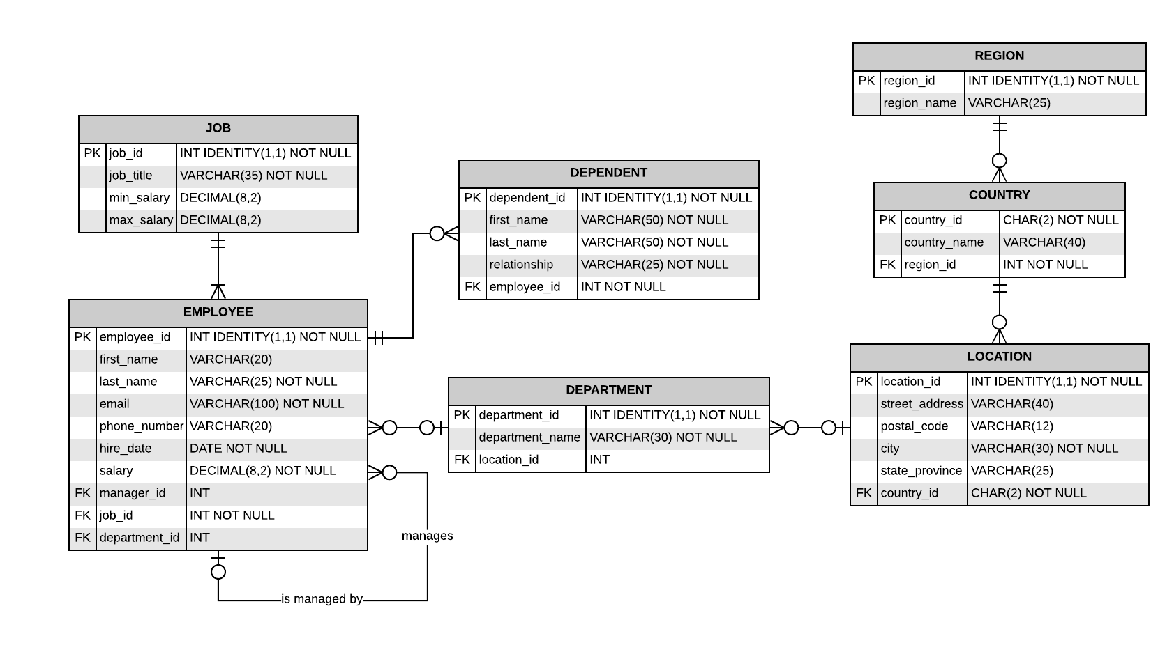

Based on the above ERD and with the **HR** database selected in SQL Server Management Studio (SSMS), write SELECT queries to answer the following questions.

**Note I**: When writing SQL code, reserved words (e.g., SELECT, FROM, etc.) shall be UPPERCASE, and identifiers (e.g., table names, column names, etc.) shall be lowercase.

**Note II**: Reserved words (e.g., date, transactions, etc.) can be used as identifiers by place square-brackets around the identifier (e.g., CREATE TABLE [transaction]).

1. Write a SQL statement to display all records in the employee table.

select * from employee;

1. Write a SQL statement to display the first and last names of all employee dependents.

select first_name, last_name from dependent;

1. Write a SQL statement to display all job details that have a minimum salary greater than 10000. Sort the results based on the highest to lowest minimum salary.

select * from job

where min_salary > 10000

order by min_salary desc;

1. Write a SQL statement to display the street address, city, and state/province of all locations. Sort the results based on each record's state/province.

select street_address, city, state_province from location

order by state_province asc;

1. Write a SQL statement to display each employee's first and last name as a single field (i.e., "Mark Buckner", with a space between the first and last name) and their salaries. Call the concatenated column "Name". Sort the results so that the person with the highest salary is listed first.

select first_name + ' ' + last_name as "Name", salary from employee

order by salary desc;

1. Write a SQL statement to display all employees who do not have a manager.

select * from employee

where manager_id is null;

1. Write a SQL statement to display a list of all location's state/provinces. Do not include any NULL results. Ensure the results do not have duplicate state/provinces and are sorted in alphabetical order.

select state_province from location

where state_province is not null

order by state_province desc;

1. Write a SQL statement to display all employees first and last names, their current salary, and what their salaries would be with a 2.3% increase. Call the salary increase field, "Salary with raise."

select first_name, last_name, salary, (salary * 1.023) as "Salary With Raise" from employee

;

1. Write a SQL statement to display the first name, last name, and date of hire for all employees hired between 1985 and 1988.

select first_name, last_name, hire_date from employee

where hire_date between '1985' and '1988';

1. Write a SQL statement to concatenate each employee's information to display like the sentence below. You may need to use some "Google-Fu" to overcome a data type casting error…

"Mark Buckner was hired on 1982/04/17."

select (first_name + ' ' + Last_name + ' was hired on ' + convert(varchar,hire_date)) as "Google-Fu" from employee;

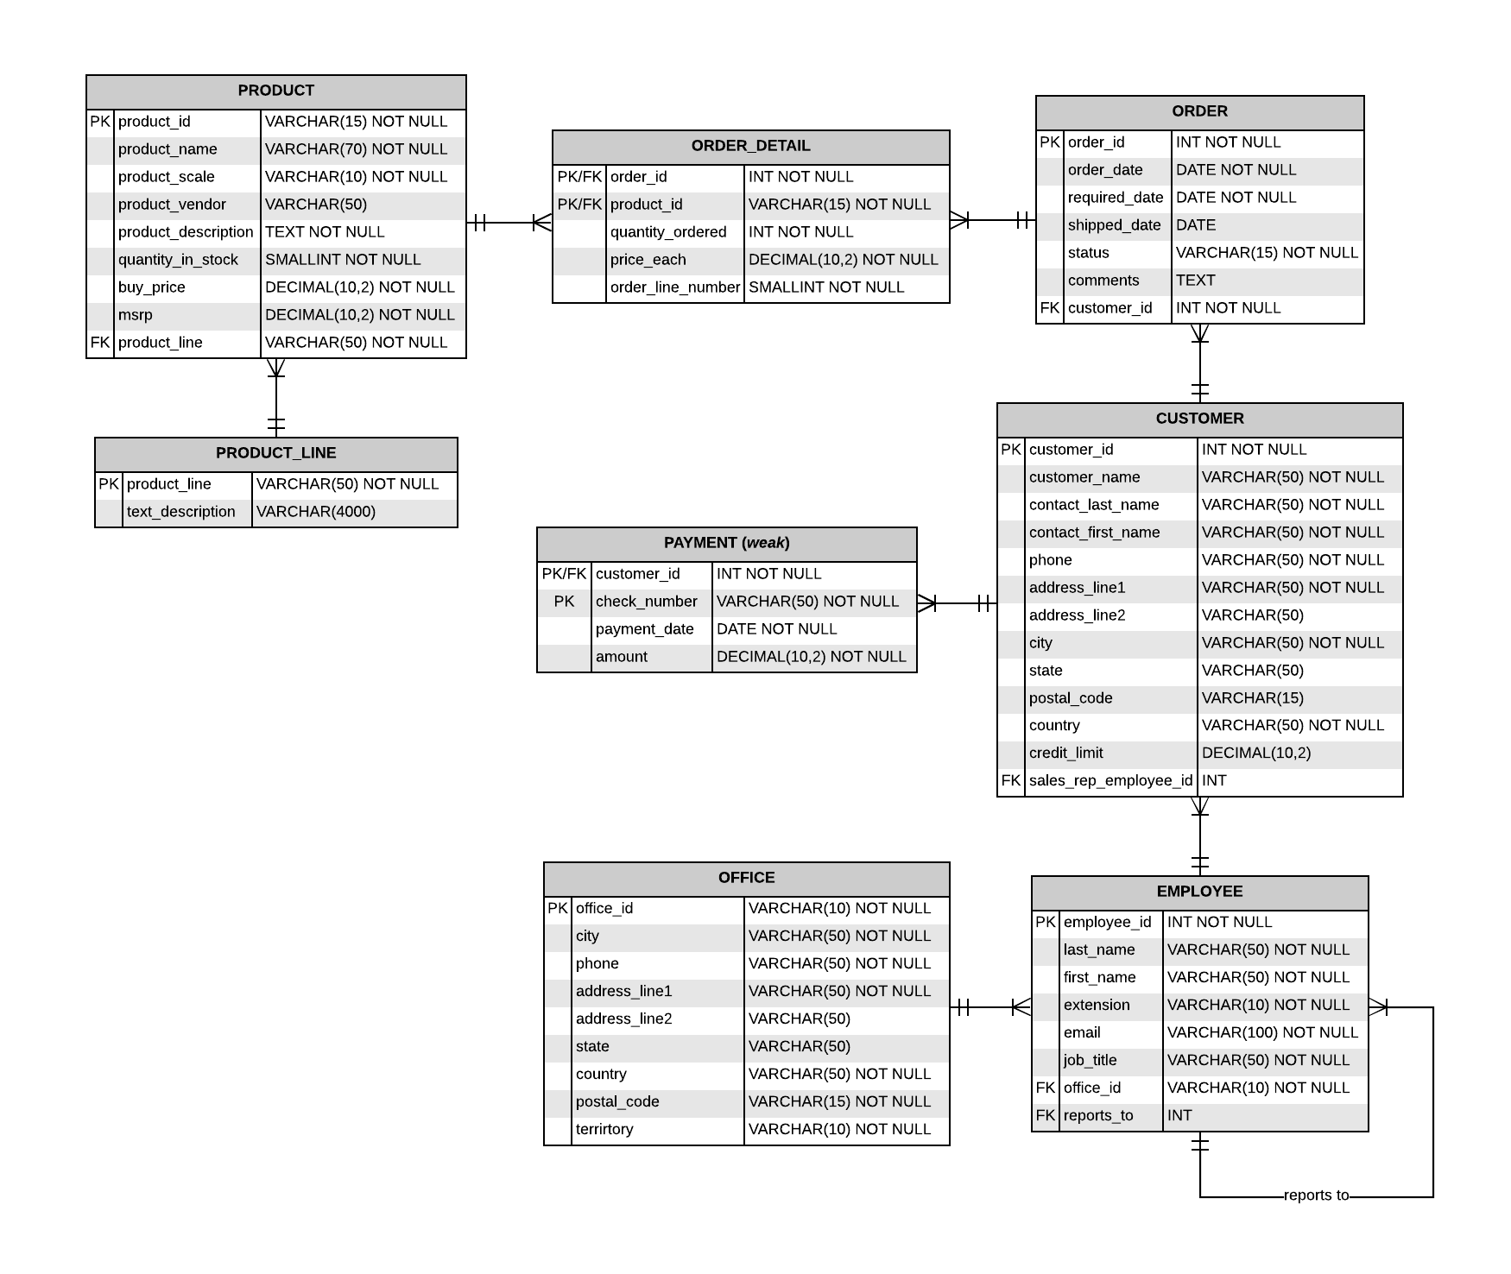

Based on the above ERD and with the **ClassicToys** database selected in SQL Server Management Studio (SSMS), write SELECT queries to answer the following questions.

**Note I**: When writing SQL code, reserved words (e.g., SELECT, FROM, etc.) shall be UPPERCASE, and identifiers (e.g., table names, column names, etc.) shall be lowercase.

**Note II**: Reserved words (e.g., date, transactions, etc.) can be used as identifiers by place square-brackets around the identifier (e.g., CREATE TABLE [transaction]).

1. Write a SQL statement to display all records in the product line table. Sort the results in alphabetical order.

select * from product_line

order by product_line asc;

1. Write a SQL statement to display all product names and their manufacturer suggested retail price. Sort the results from most expensive to least expensive.

select product_name, msrp from product

order by msrp desc;

1. Write a SQL statement to display a list of customer names and credit limits who have a credit limit greater than zero. Sort the results from highest to lowest credit limit.

select customer_name, credit_limit from customer

where credit_limit > 0

order by credit_limit desc;

1. Write a SQL statement to display all orders placed in 2003 in chronological order.

select * from "order"

where order_date between '2003' and '2004'

order by order_date asc;

1. Write a SQL statement to concatenate each customer's information to display like the sentence below. Alias the column as "Customer Information". Use the customer table's contact's first and last name.

"Mark Buckner lives at 10 Elm Street in Morristown, TN 37826 in the United States."

select (contact_first_name + ' ' + contact_last_name + ' lives at ' + address_line1

+ ' ' + address_line2 + ' in ' + city + ', ' + "state" + ' ' +

postal_code + ' in the country ' + country + '.') as "Customer Information"

from customer;

**Submission Instructions**

* Upload this document to the appropriate dropbox on D2L.